Picture Reading
Look at the following pictures. Can you identify them ? Think and tell your teacher the same.

An old King An old Queen
A beautiful baby

A Fairy Spindle Young and beautiful Princess

Staircase

Handsome Prince
Rusty Key
Thorny Bushes

Magnificent Wedding

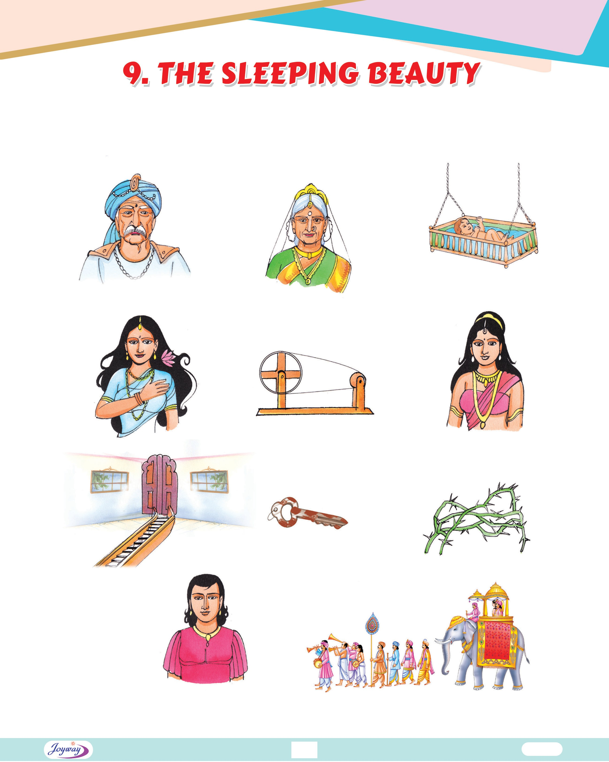

49 English-4


Grammatical Awareness


Adjectives of Quality
Adjectives that show the quality, kind or condition of a person or thing are called Adjectives of Quality. They are also called Descriptive Adjectives.
Adjectives of Quality in Animal World

A Lean Hen A Fat Cat

An Old Owl

A Young Yak

A Tall Giraffe
A White Rabbit

A Pretty Parrot
An Ugly Eagle

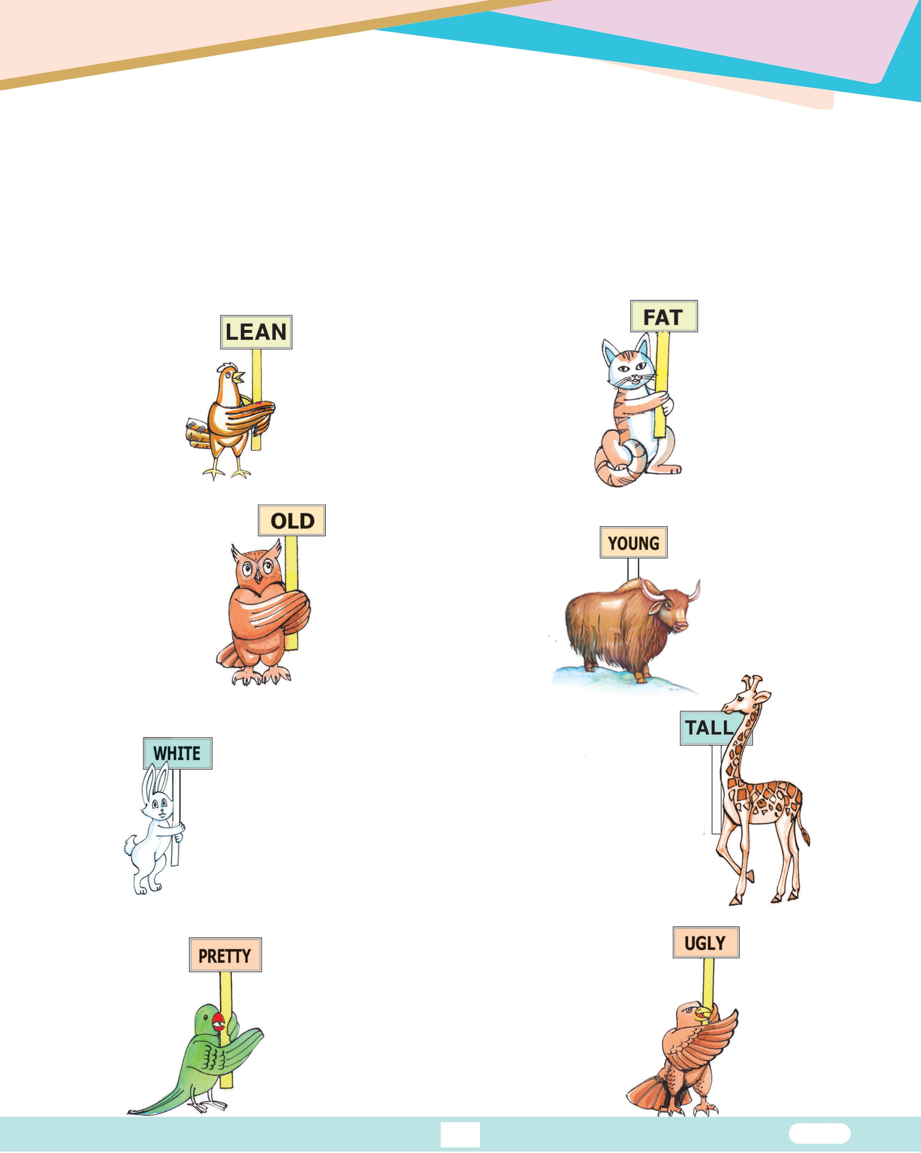

50 English-4

A Dirty Dog A Neat Dove A Big Pig

A Small Lion A Clever Fox

Some More Examples :
Mumbai is a large city.
I ate some ripe mangoes and seedless grapes. The child has a smiling face.
They lived in a big red house. Mr. Ramesh is a kind man.
The camel is a very useful animal. The dog is a faithful one.
These small apples have a sweet taste. Mr. Suman bought a new car.
We have warm weather in Summer.
A Foolish Camel

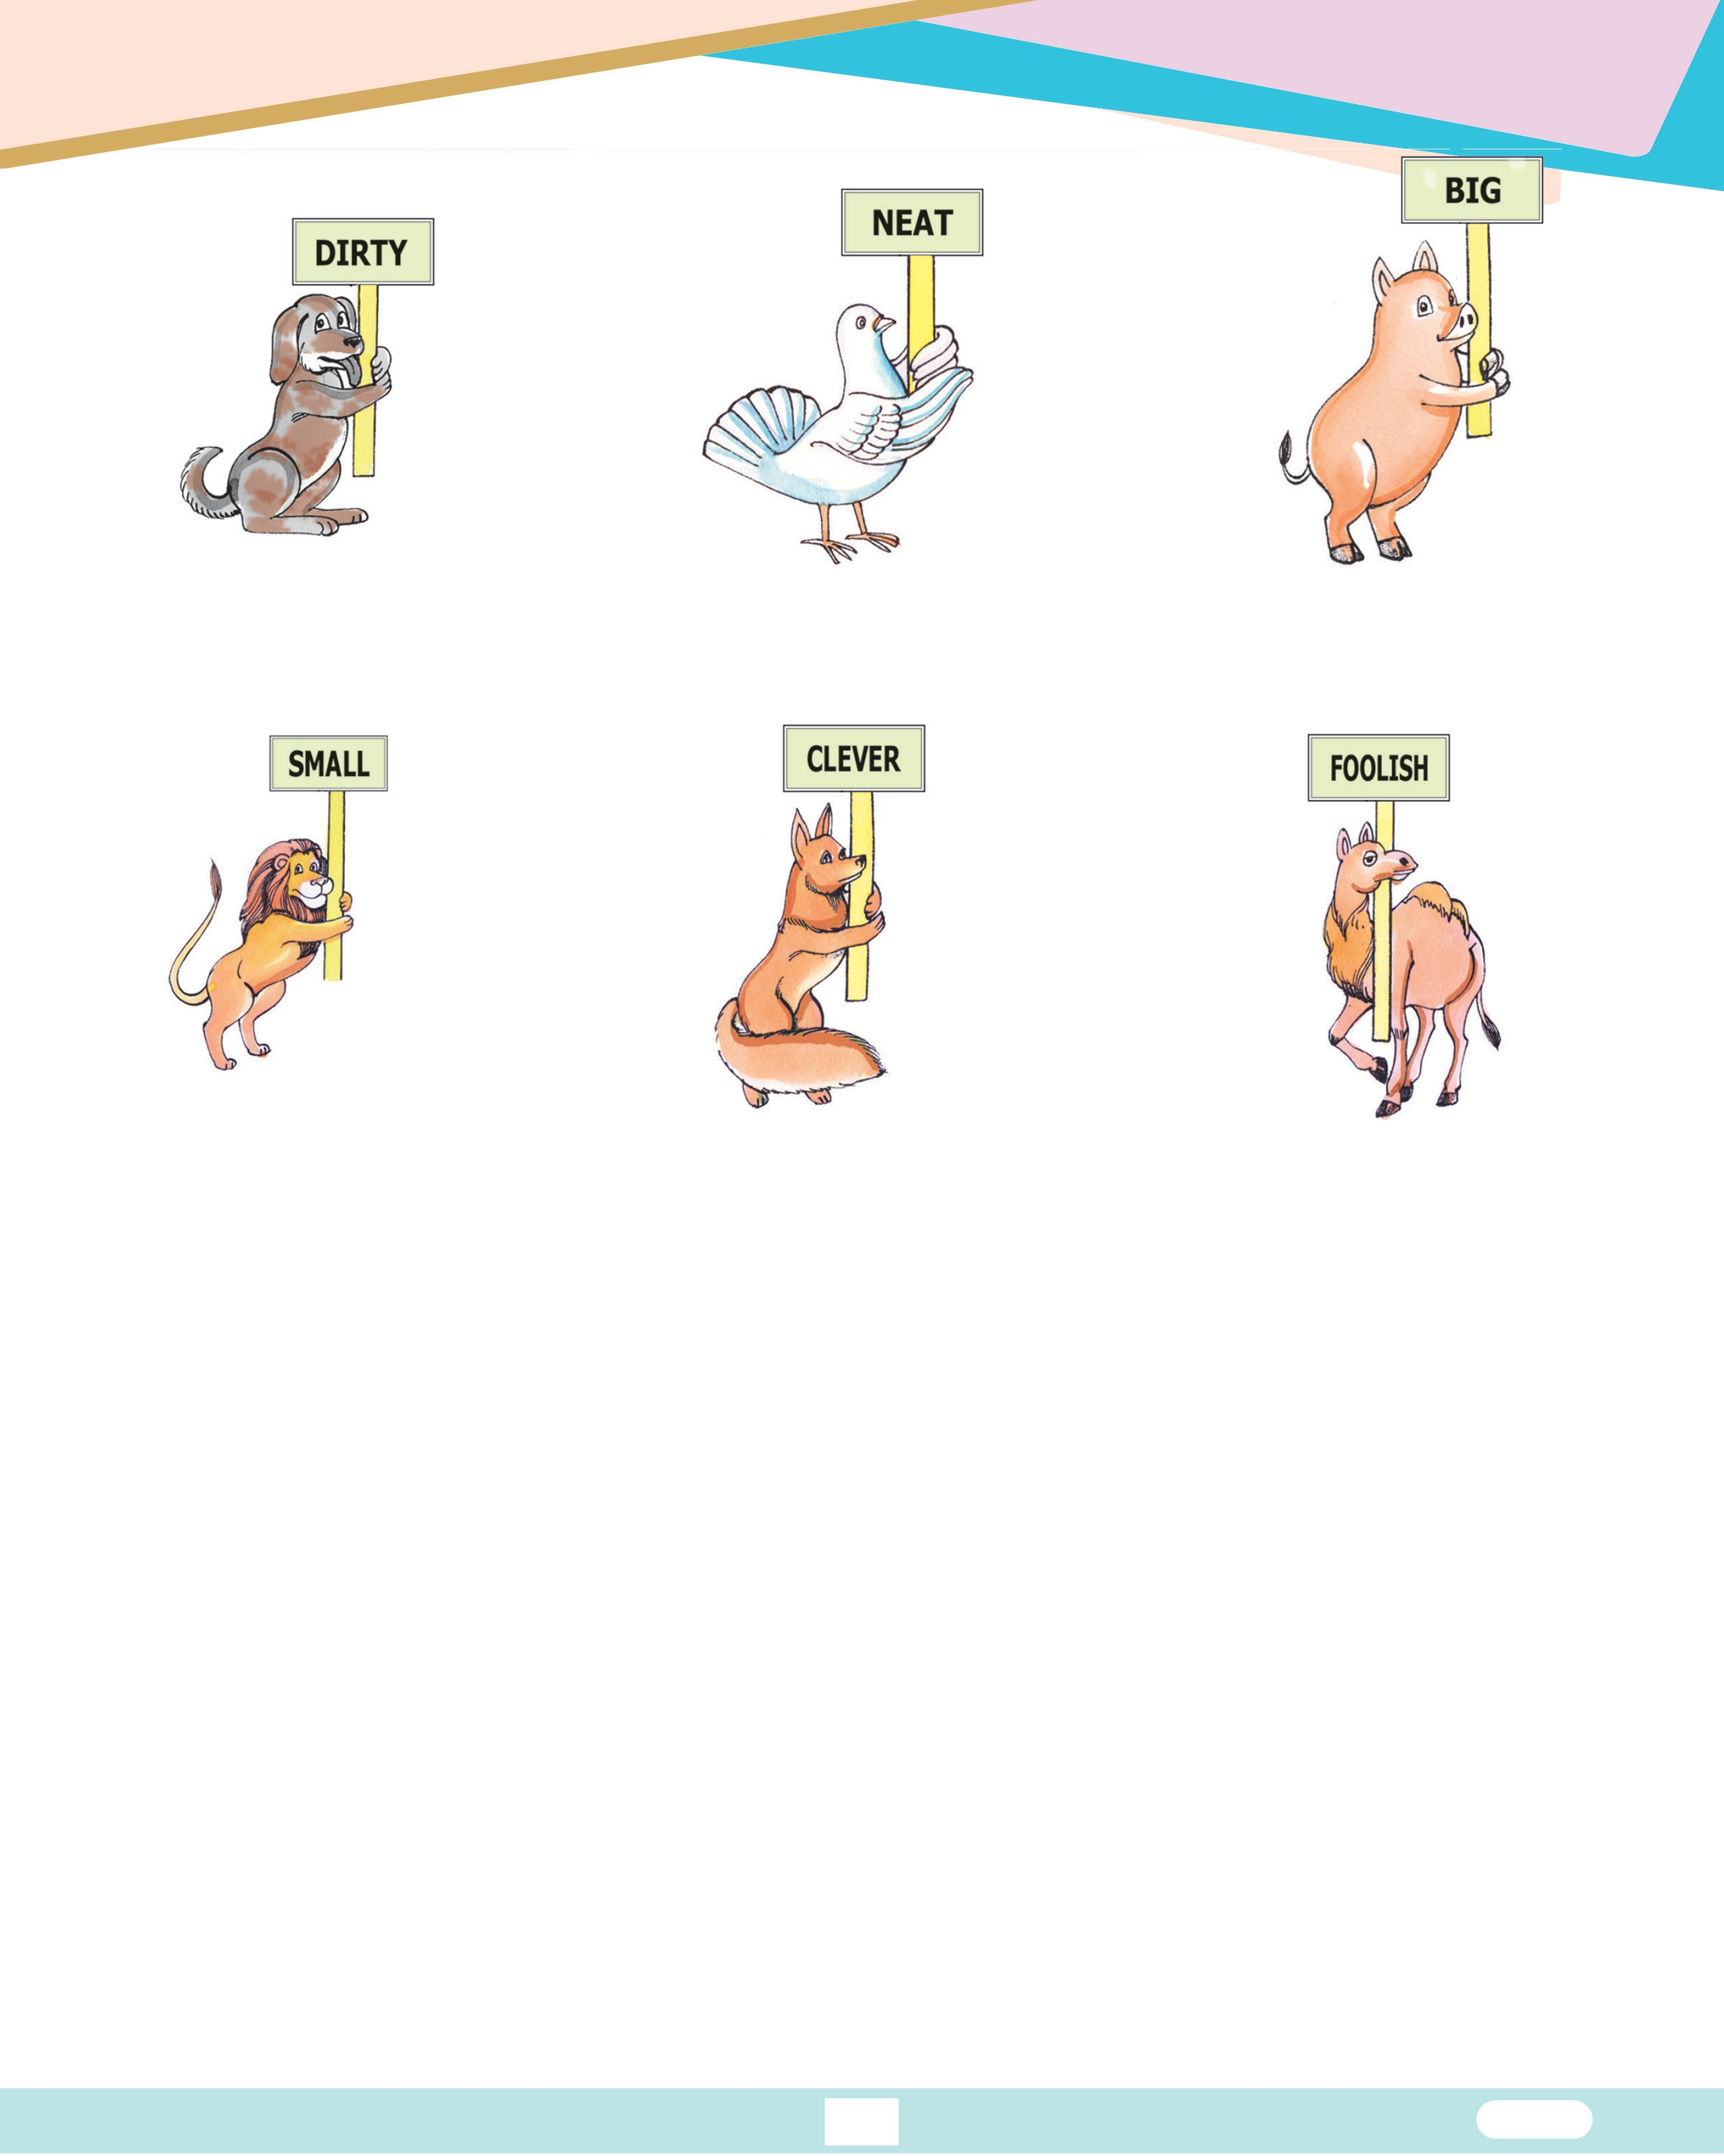
Note : Adjectives of quality always answer the question, “Of what kind.”

51 English-4

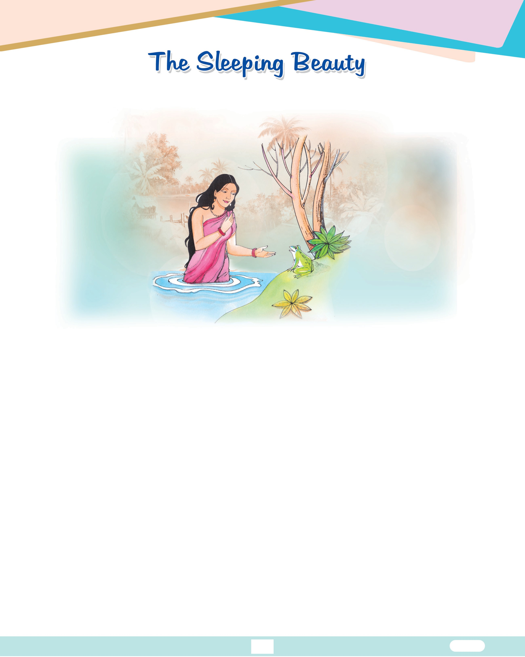


Reading

Long, long ago, there lived a king and a queen who longed for a baby. One day, when the queen was bathing in the lake, a frog jumped out of the water and said, “Before
the end of this year, your wish to have a baby will be granted.”

A few days later the prediction of the frog came true and the Queen gave birth to a beautiful baby girl and she decided to have a grand christening ceremony. They have not only invited their relatives and friends, but also invited the twelve good fairies to be godmothers. However, there were thirteen fairies in the land, but the king had forgotten the thirteenth as she lived alone faraway in a castle and she was not invited. That proved a grave mistake for the King and Queen and they soon realized their mistake.
The christening was held grandly and when it was almost over, the good fairies went up to the cradle and bestowed gifts on the baby. One gave her gift of virtue, another, beauty and another, wealth and the baby Princess had all the gifts. When the eleventh fairy had bestowed her gift, the thirteenth fairy came and said, “I am going to give her a gift which will never allow her to forget me.” She shouted and wailed, “On her sixteenth birthday, the Princess will prick herself with a spindle and will die.”
52 English-4

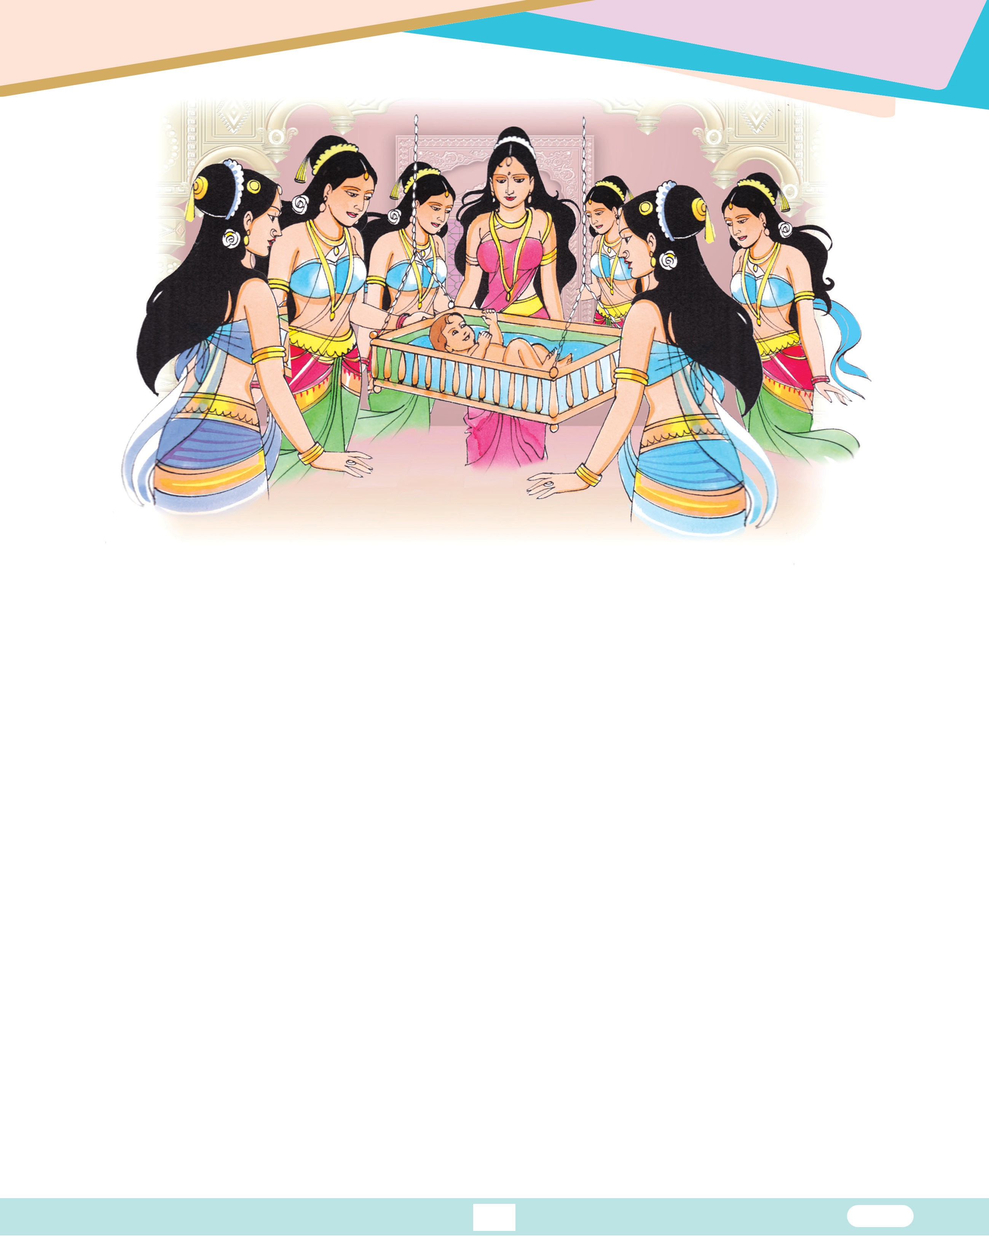

All the members were dumbstruck but the twelfth fairy came and as she had the power to lift the wicked curse, she eased it saying, “Take comfort. The Princess won’t die, but falls into deep sleep for hundred years when she pricks her finger on the spindle.”
The king ordered all the spindles to be banned and burnt as the hope that he would save his daughter from the magic spell of the thirteenth fairy. He regretted not inviting her to the christening.
The years flew and the princess grew up to be kind and beautiful and was loved by all. On her sixteenth birthday her parents were away for part of the day. So the princess was alone for most of the day.
She wandered all over the palace and had a look at all the places where she had never been before. Finally, she came to a winding staircase which led to a tower. She climbed up the staircase and reached a little door with a rusty key in the lock. When she turned it, the door opened and she found an old woman busily spinning flax on a spindle.

53 English-4

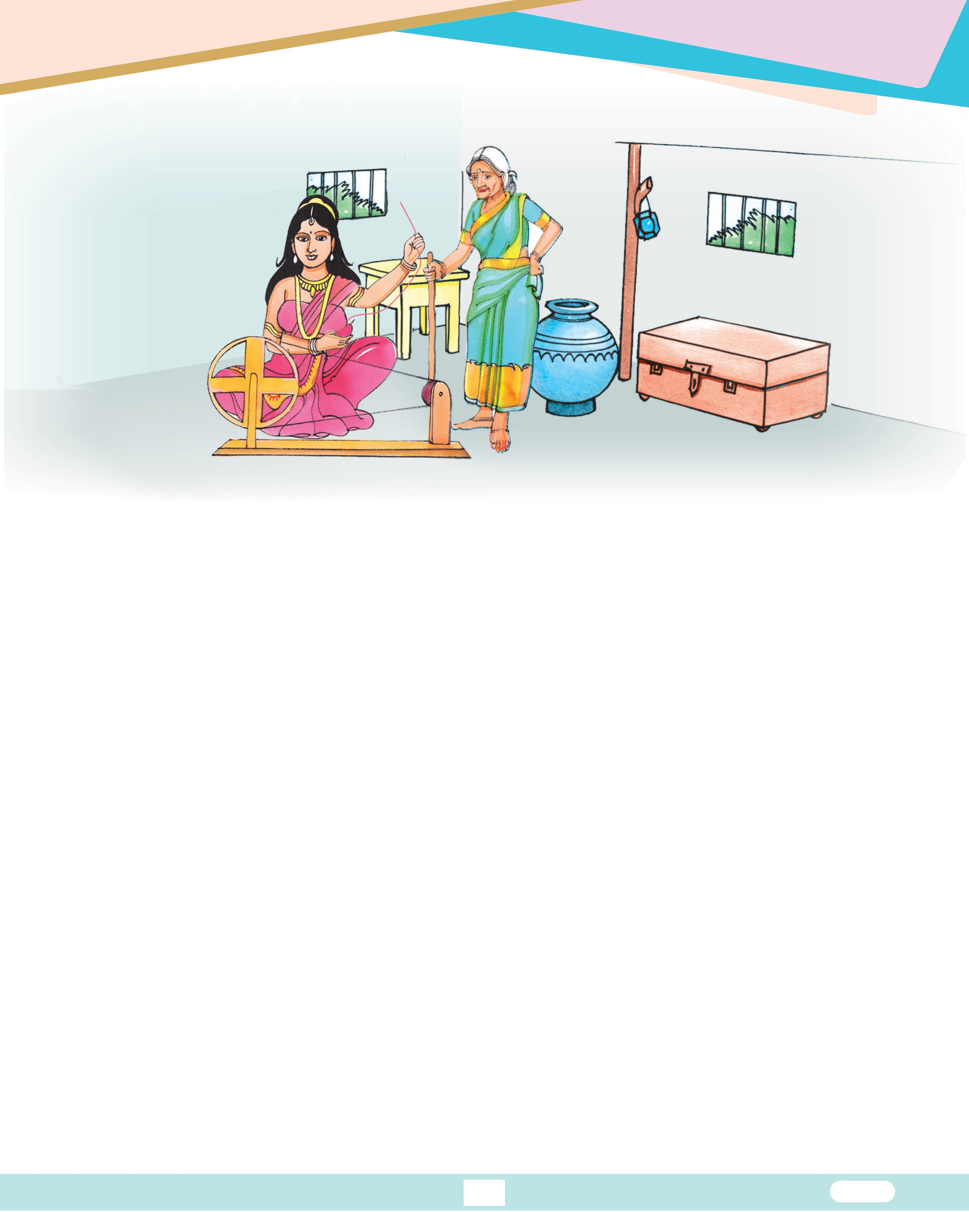

The old woman greeted her and invited her. The princess asked her, “What are you doing ?” The old woman replied, “I’m spinning yarn.” The princess then asked, “What is that thing that is jumping up and down ?”. “That’s a spindle,” replied the old woman, “Will you try it ?” The princess took the spindle and began to spin.
As soon as she touched the spindle, she fell asleep. The whole palace along with her parents who have just arrived also fell asleep. There was not even the rustle of the dry leaf as everybody and everything have slept peacefully.
A hedge of thorns grew up around the palace. Every year the hedge grew higher and
thicker and eventually the flag on the palace roof could no longer be seen.
The story of the sleeping beauty became a legend in that land. From time to time princes went to cut the thorns, but they failed in their attempts. So almost all of them gave up the idea of searching for the Sleeping Beauty.
After a hundred years, a prince heard about the story of the Sleeping Beauty. He knew about the attempts of the other princes who have failed and he thought, “I want to go and find the lovely Sleeping Beauty for myself,” saying so he rode to the hedge of thorns and a mysterious thing happened.

54 English-4

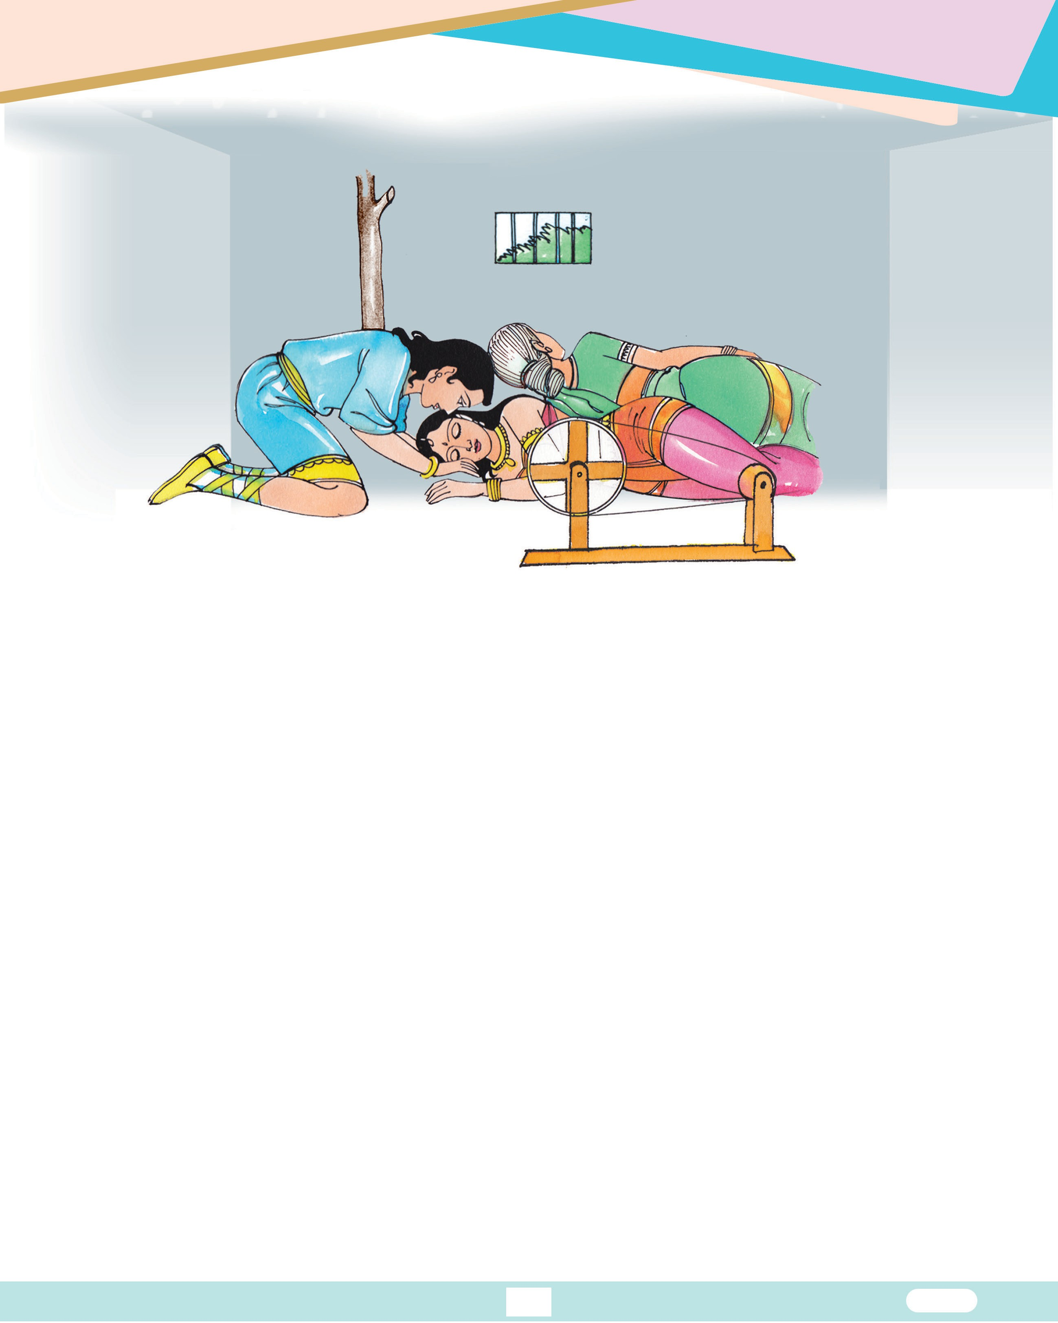

When he was about to cut the wild hedge of thorns a path opened up, and the prince rode straight into the palace. The wild thorns closed up to form a hedge once more.
The prince saw the horses, dogs, birds asleep. He looked around and saw the king and queen also fast asleep.
Finally, he came to the tower and opened the door to the little room where the princess lay sleeping. She looked so beautiful that he bent down to kiss her on the lips. As his lips touched hers, the Sleeping Beauty awoke and fell in love with the prince at first sight.
The rest of the palace awoke after their long sleep. It seemed as though time had stood still and those long, long years had never passed.
The spell was lifted at last and the darkest days were finished. Soon everyone enjoyed the magnificent Wedding Reception of Sleeping Beauty. The prince and the Sleeping Beauty lived happily thereafter. No one ever saw or heard about that troublesome thirteenth fairy.
S
55 English-4



Listening & Speaking
- This section is aimed at improving the student’s oral communication. Encourage the student to take up the role play.
Witch : The princess will never forget me in her life.
Queen : Please forgive us. Do not bestow a curse on our princess.
King : We beg for your pardon. Don’t do it to our daughter.
Witch : The princess in her sixteenth year will prick herself with a spindle and die.

Stress The Right Way
- This section is aimed at improving the student’s pronunciation. STRESS the capital letters in the words.

PREdict | CEremony | aTTEMPT
MYSTErious | CAstle | beSTOW
WANder | VIRtue | CHRIStened


Glossary
Spell And Tell
- Learn the meanings of the words.

Predict : to tell in advance, foretell
Christened : a ceremony conducted for naming a child Bestow : present
Castle : palace
Virtue : goodness
Curse : evil, misfortune
Prick : drive a sharp point into Hedge : a fence formed by bushes

56 English-4



Comprehension

Answer the following questions.
    - What did the frog tell the queen ?
    - What is the mistake committed by the king and queen ?
    - What is the curse given by the thirteenth fairy ?
    - What happened on the princess’ sixteenth birthday ?
    - At last, who had woken up the princess ?


Vocabulary

Watch & Match : Match the words that go together. The first one is done for you.

1. big | ( e | ) a. | elephant
2. wise | ( | ) b. | owl
3. strong | ( | ) c. | cow
4. ugly | ( | ) d. | Solomon
5. healthy | ( | ) e. | building


Grammar
  - Fill & Drill : Fill in the blanks with Adjectives of Quality. See ‘take My Help’.


    - He is an man.
Take My Help :
- big
- good
- tall
- honest
- intelligent

    - The child fell down from a tree.

    - Swimming is a exercise.

    - The elephant is a animal.

    - Ram is an boy.

57 English-4


Pick & tick : Pick out the Adjectives of Quality and tick them. The first one is
done for you.
✓
    - The thirteenth fairy was a wicked woman.
    - Chocolates are very sweet.
    - The greedy man killed the golden hen for money.
    - Chennai is a large city.
    - The prince was very handsome.


Fun Time

Become An Artist ! Show the following Descriptive Adjectives by drawing pictures.

    - A fat cat

    - A smiling face

    - A broken egg

    - A small bicycle

58 English-4

